Heaven of Hairs – Website Project Overview

Core Features
Home Page
A visually appealing landing page designed to create a strong first impression. It will highlight your brand identity, key services, offers, and call-to-action buttons for booking and contact.
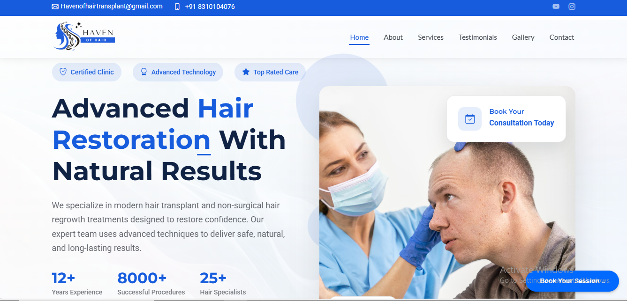
About Page
Tells the story of Heaven of Hairs — your vision, expertise, and values. Helps build trust and emotional connection with visitors.
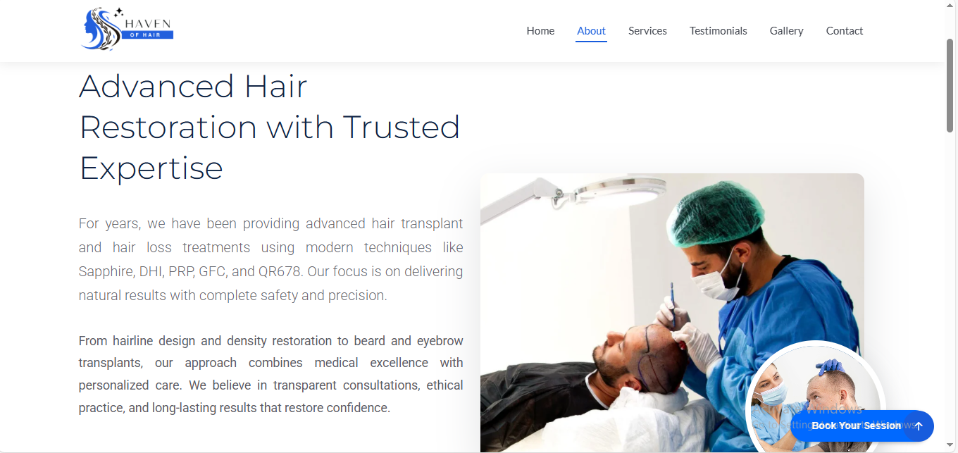

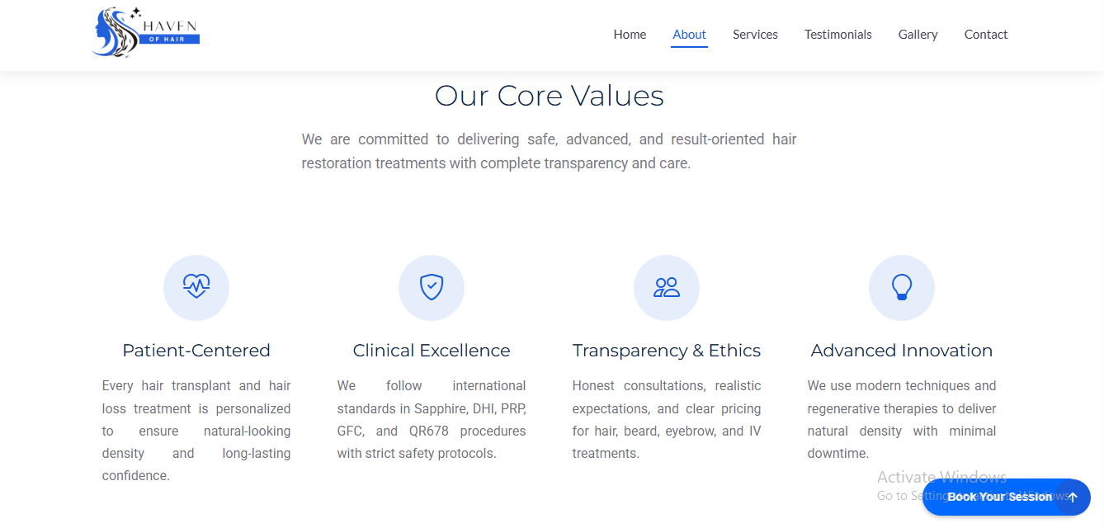
Services Page
A well-structured section showcasing all services with clear descriptions, pricing (if required), and benefits to help customers make quick decisions.
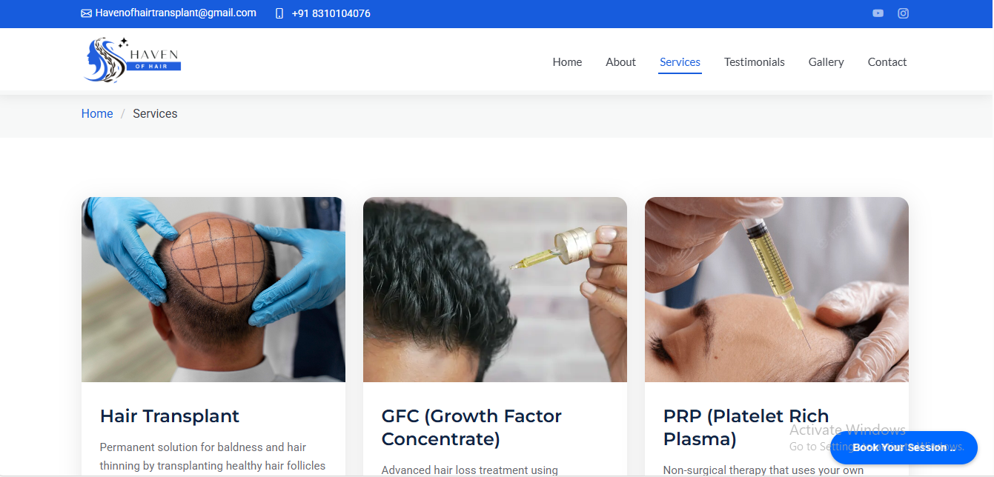
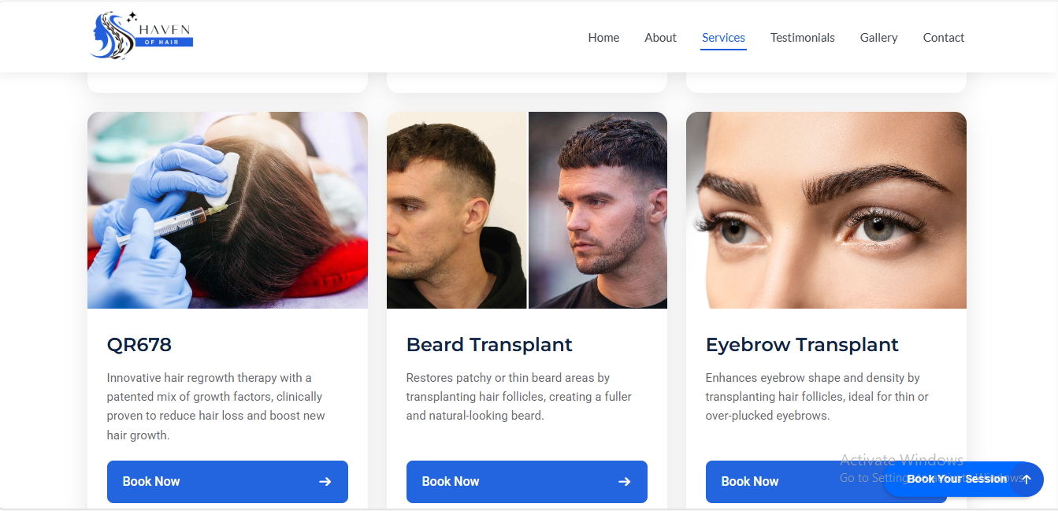
Gallery Section
High-quality image gallery displaying your work, transformations, and environment to visually attract and convince potential clients.
In Progress
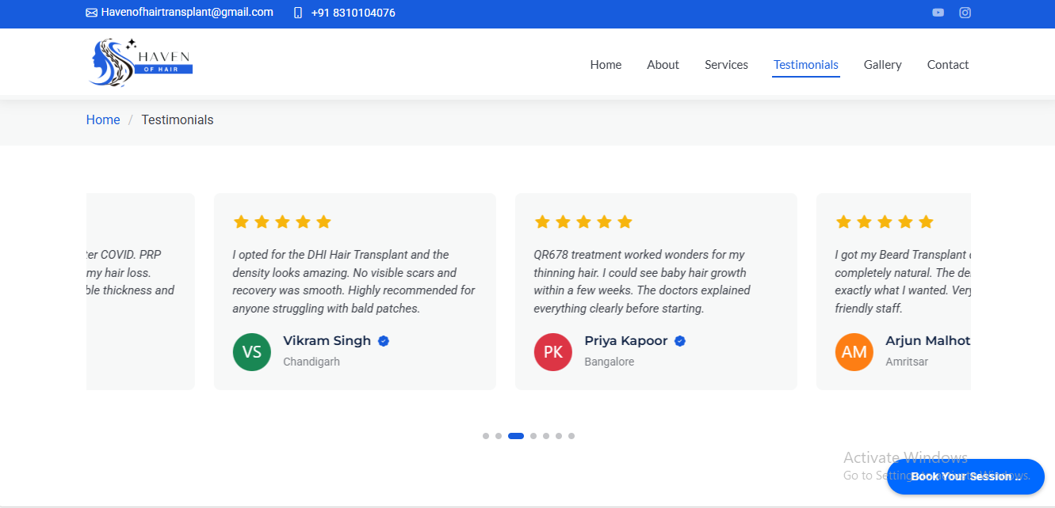
Contact Us & Booking System
Contact form with quick inquiry option, live chat support for real-time communication, appointment scheduling for visits, and an admin mobile app (Android & iOS) to manage chats.
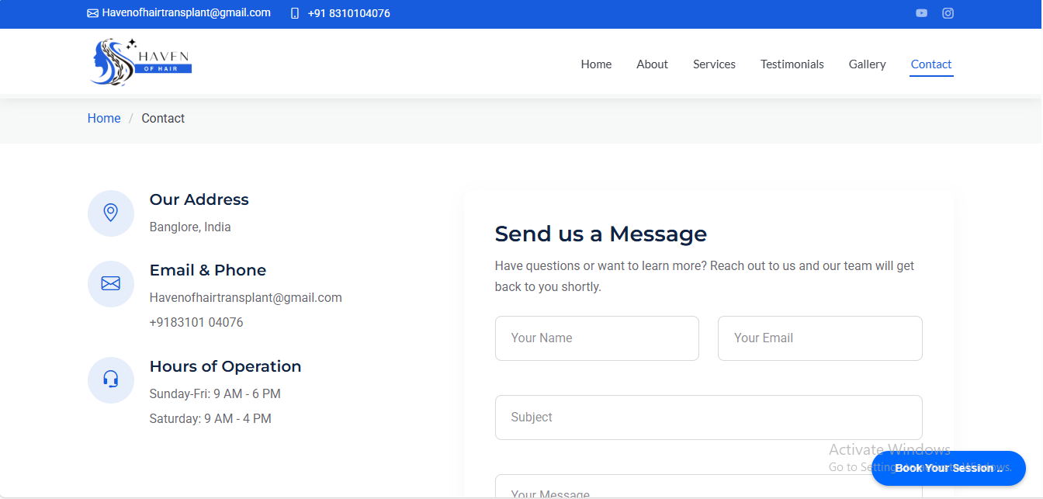
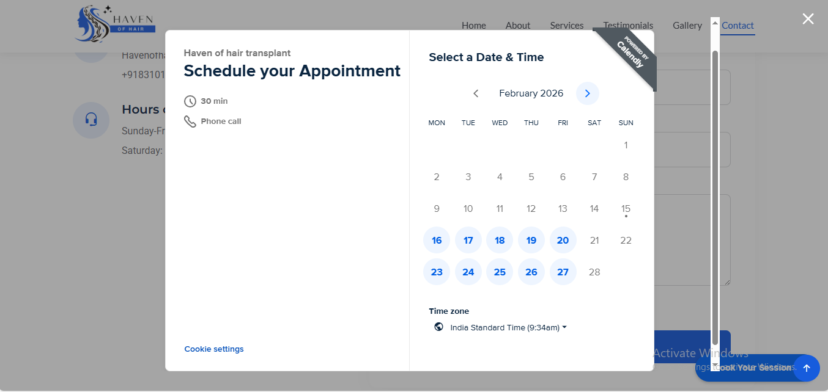

Live Chat:
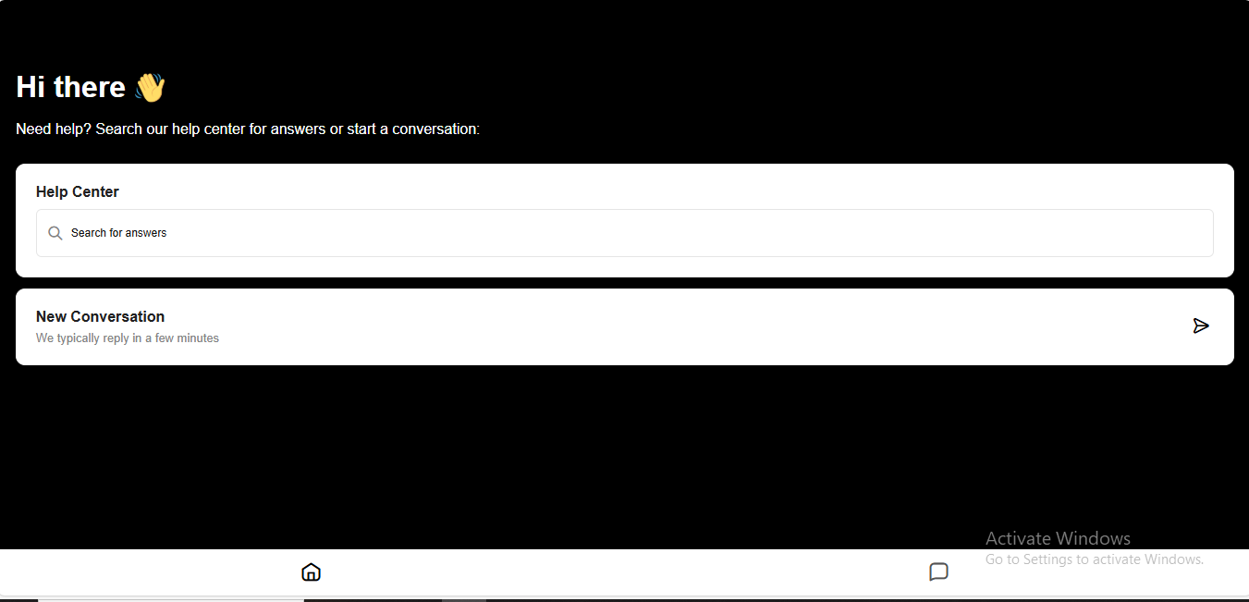

There are additional efforts, Added to make website more better.
Terms of Service Page:
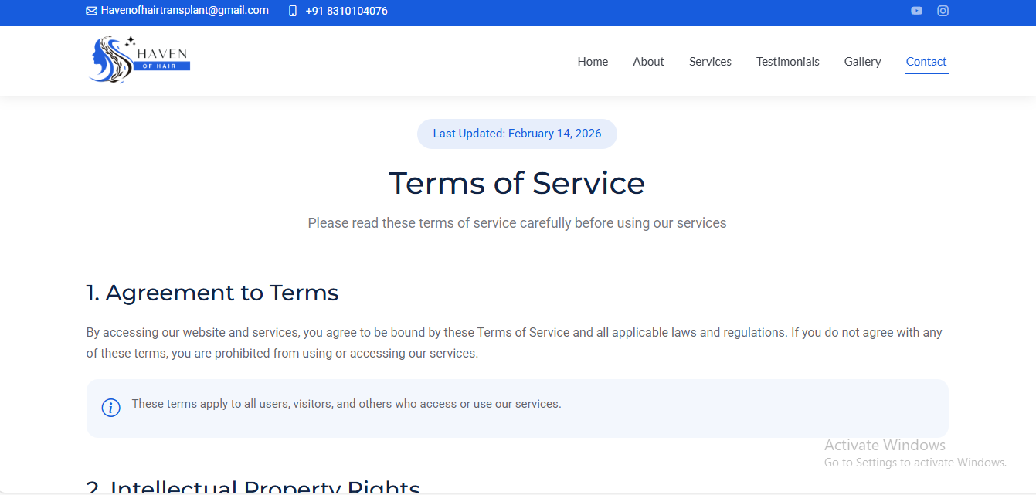
Privacy Policy Page:
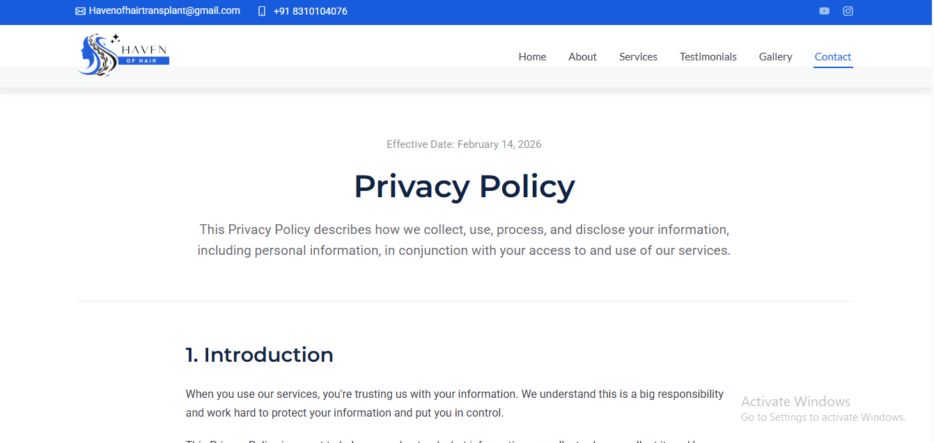

Additional Value We Provide
- Up to 2 design/content revisions included
- Analytics integration to track website traffic, visitor locations, and user behavior
- Content and logo support (basic content writing and logo refinement if required)

Pricing Details
Website Development Charges: ₹16,000
Hosting Charges: Free for the first year
Domain Name: To be purchased by the client (recommended: GoDaddy Hostinger)

